|  |  |
| --- | --- |
| **CLIENT DATA** | |
| **Company name: Paradigma Spa.** | |
| **Contact: Phillip R. Roe-Smithson** | **Mobile: + 56 9 82928644** |
| **Date: December 10, 2018** | **e-mail: proe@paradigma.cl** |
| **Document Name: PAR.D.01.116.001** |  |

**Problem: To know information about a container in the whole journey from the point of origin to the point of destination.**

**Introduction**

The use of containers to transport merchandise is the most used means today, mainly through boats and trucks. Knowing in real time the location of the container and also environmental information that is inside the container, for example T°, Humidity, O2, etc…, it is a very important information for importers/exporters of merchandise.

Each container, from the moment it is closed at the point of departure until it is opened at its point of destination, goes through many parts and during the whole journey, situations may occur that the importer/exporter must know, for example if the container It was opened, if it suffered a major fall, if the cold chain broke, etc…

It is sought to have an electronic solution that automatically transmits periodically to the cloud the position in which the container is located and also information generated inside the container.

**Background**

* The container is transported both by land (trucks) and by sea (container ships).
* It is required to transmit periodically to the cloud, information generated inside the containers (sensors) and also their geographical location. For this, the solution to be implemented must include some environmental parameter sensors.
* Being able to get information from inside the container to be transmitted to the cloud is an important problem to solve. There is a solution in the market called Triton, which is in patent process (not yet granted) and that solves this problem.

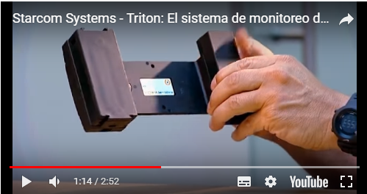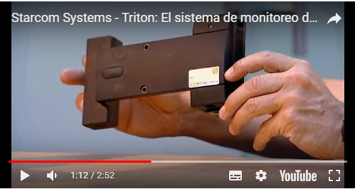

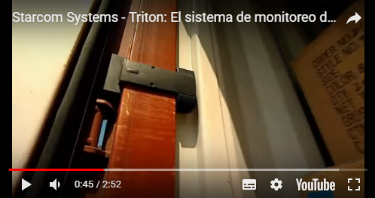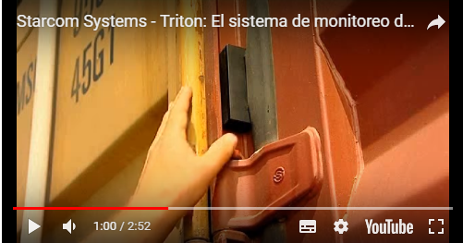

* During the transit of the container, there are areas where there is no cellular coverage, so at least the following two communication channels must be included: Satellite Cell.
* To know where the container is located, GPS is used.
* When the container is in a truck, the information captured from the sensors that are inside the container, can easily be transmitted to the cloud, using the cellular network or satellite channel. In case the container is on a ship, it could only use a satellite channel to transmit information.

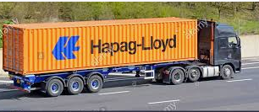

• When the container is inside a ship along with several thousand other containers, it is no longer possible to directly use the satellite channel (except for the few containers that are on the deck and also on the edges of the columns of containers). It is therefore necessary to have another communication channel that allows containers that are not on the edges of the columns of containers or under the deck of the ship, to transmit the information captured by their sensors. In order to face this second problem, we want to evaluate the use of a low power and long range wireless network.

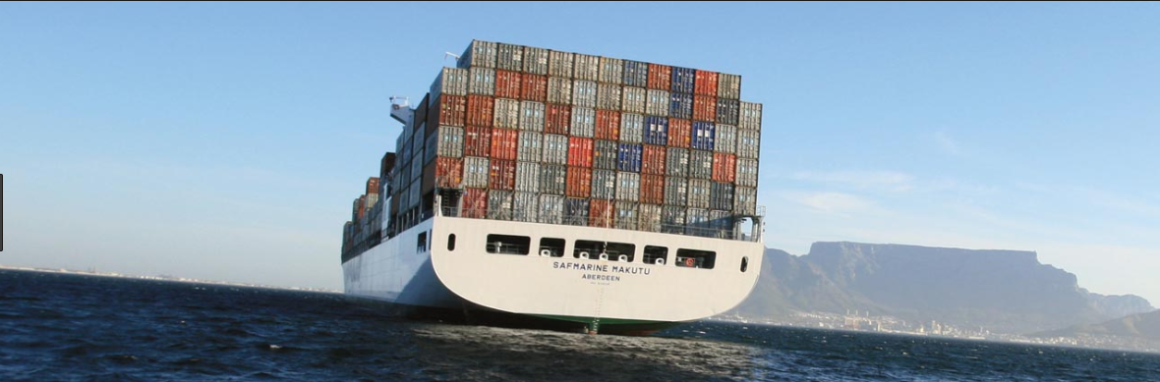

**Proposed preliminary solution**

Include in each container an electronic module that is capable of measuring from the inside of the container some environmental variables and can transmit the captured information to the cloud. When the container is in a truck, the solution to be developed can directly transmit to the cloud using a cellular MODEM (it must include SIMCARD of the countries where the container will pass) or a satellite MODEM, however this is not possible when the container It is inside a ship. To face the problem of transmitting the information of each container to some point where there is satellite coverage inside the ship, which will prove the use of Wi-SUN modules that operates as a mesh network. Ideally you want to avoid having to incorporate a GATEWAY that receives information from all the containers that are on the ship, and then transmit it to the cloud.

If for some reason at any time there is no possibility of transmitting information to the cloud, either using the cellular MODEM or satellite modem, the information will be stored and transmitted the next time you try to transmit information to the cloud.

*Notes:*

* *It is assumed that the problem of removing data from inside the container is already solved. This is the first problem to solve.*
* *GPS position is not always available. Independently of this, the information of the rest of the sensors will be transmitted in the same way.*
* *It must be defined whether the transmission of information between a particular container and the cloud will be unidirectional or bi-directional, particularly for the case where the containers are inside a ship and to be able to communicate with these units, it must be used of the WI-SUN communication channel.*
* **Elements that make up the solution:**
* **Sensors:**
* T°.
* Humidity.
* CO2.
* O2.
* Accelerometer. It allows to detect falls or strong blows suffered by the container.
* GPS. It allows you to know where in the world the container is physically located.
* Door opening.
* **Communication channels** to transmit information to the cloud**:**
* MODEM 3G.
* MODEM satellite.
* **Wi-SUN communication channel**, which will be used when the container is on a ship and does not have satellite coverage.
* **Microcontroller with BLE**. It is responsible for managing the different electronic components and also interacting with a user through a cell phone.
* **Rechargeable battery**. It must allow autonomy of at least 2 months.

• **Functioning:**

When a certain programmable time period is met, the unit installed in the container will capture data from the sensors and transmit them to the cloud, following the procedure:

* Try to use the cellular MODEM.
* If the cellular network is not available, it will try to use satellite modem.
* If satellite modem is not available, it can be assumed that the container is inside a ship and will try to transmit information through WI-SUN. Through this mesh network, the information will travel to a point where there is communication with a satellite, in which case it will transmit the information received.

*Note:*

*The behavior of the mesh network should be studied to determine if one or more GATEWAYs are required on the ship, for example to extract information from a container warehouse located under the deck of the ship (may be several floors). In this case, a GATEWAY per floor may be required. All GATEWAYS must be wired to transmit the information to the deck of the ship.*

*The GATEWAY On the deck of the boat.*

**POC**

It is proposed to develop a proof of concept (POC), to validate the idea, mainly the following:

1. It is possible to extract data from a container without having to pass on any valid patent.
2. It is possible to use the WI-SUN network to transmit information generated in a container located at the center of a container storage yard, to a point outside the container yard. It seeks to emulate what could happen inside a ship.
3. Study option of bi directionality in the communication using WI-SUN network.
4. Develop a hardware that includes some sensors, such as temperature, humidity, O2, CO2 GPS and that includes a 3G MODEM, a satellite MODEM and a WI-SUN module. At least 6 units are required to be able to carry out operational tests in a container yard in Stgo.